QUICK CAB

S5 DBMS MINI PROJECT

TEAM MEMBERS :

RINU TONY, R.N-35
NANDHA BIJU, R.N-5
SIONA KURISINKAL, R.N-50
NITHA THERES GEORGE, R.N-19

DATE OF SUBMISSION : 14-11-2024

INTRODUCTION

In today’s fast-paced urban environment, the struggle to secure reliable, convenient, and comfortable transportation has become a common frustration for many commuters. Traditional cab booking services, while accessible, often lack the ability to cater to the unique needs and preferences of individual riders. Issues such as limited in-car amenities, inconsistent service quality, and a lack of personalized options mean that passengers frequently feel like just another booking rather than a valued client. The need for a more tailored experience is evident as consumers increasingly expect technology-driven personalization in every service they use.

This report introduces a new approach to cab booking, with a platform designed to address these gaps by offering an enhanced, user-centric experience that goes beyond standard ride-hailing services. Our newly developed cab booking website provides clients with a range of personalization features, allowing them to tailor their rides based on specific preferences such as Bluetooth connectivity, in-car Wi-Fi, Spotify integration, and more. By allowing users to customize these elements, the platform not only simplifies the booking process but also offers a premium, personalized travel experience that aligns with individual needs.

The goal of this platform is to alleviate common cab booking frustrations by offering a seamless, intuitive interface where clients can easily select and save their ride preferences. From business travellers requiring uninterrupted Wi-Fi access to passengers seeking control over the music they listen to, the platform provides flexibility and convenience, fostering greater satisfaction and customer loyalty.

This report explores the development of this personalized cab booking website, detailing the features, benefits, and technological advancements that set it apart in a competitive market. By examining the specific challenges of integrating external services like Spotify and Bluetooth, we provide insights into how this platform overcomes current limitations in cab booking, creating a more satisfying, customized experience for modern travellers.

PROBLEM DEFINITION

The modern cab booking market often fails to meet today’s user demands for a more customized and consistent in-ride experience. Despite the popularity of traditional services, these platforms typically do not accommodate individual preferences, leading to issues with service quality, in-ride amenities, and user convenience. This report highlights the key challenges in existing cab booking services and presents solutions to create a more personalized, user-centric platform.

Challenges in Existing Cab Booking Services
- Lack of Personalization Options: Existing platforms do not allow users to tailor their ride experiences with specific preferences, missing opportunities to enhance satisfaction.
- Inconsistent Service Quality: Riders often encounter inconsistent service quality due to differences in driver behaviour, vehicle standards, and availability of amenities, resulting in variable user satisfaction.
- Inadequate In-Ride Amenities: Current platforms do not provide essential connectivity and entertainment options, such as internet access or music control, which limits the appeal for many modern users.
- Limited Data Usage and User Preferences: Existing services rarely use user data to create a personalized experience, meaning clients receive generic offerings rather than customized options that fit their needs.

Solutions
- Introduce In-Ride Personalization Options
  - Implement features like Bluetooth connectivity, in-car Wi-Fi, Spotify integration, and climate control. Users can select these preferences during booking for a more personalised experience.

- Enhance Security and Data Privacy Measures
  - Given the sensitivity of storing user preferences, implement robust encryption and privacy protocols to protect customer data. By ensuring data security, the platform will build trust and demonstrate commitment to user safety and compliance with privacy regulations.
ER DIAGRAM

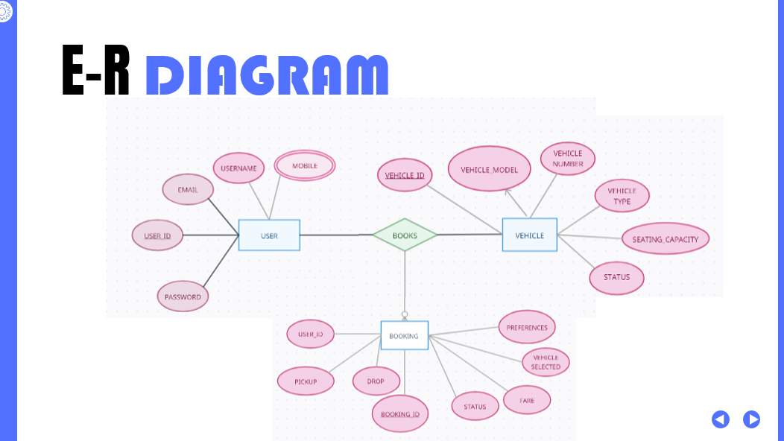

ARCHITECTURAL DIAGRAM

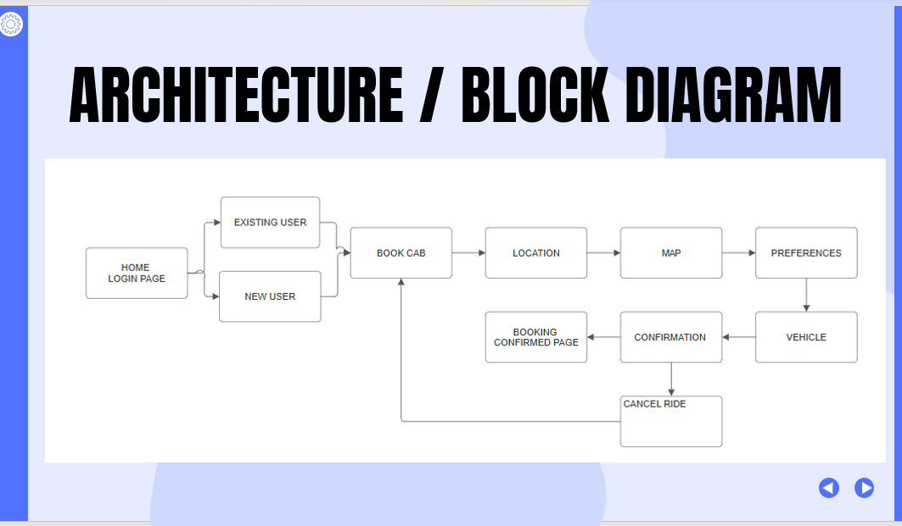

FUNCTIONALITY ACHIEVED

1. User Registration and Authentication
The User Registration and Authentication feature provides secure, user-friendly access to the cab booking platform. New users can create accounts by entering basic information, which is securely stored with hashed passwords to protect credentials. Registered users can log in with their username or email and password, which are validated against stored hashes to prevent unauthorized access. Basic email-password login and session management ensure that users can easily access their accounts without repeated logins during a session, balancing security with convenience.

2. User Profile Management Functionality
The User Profile Management feature allows users to easily view, edit, and save personal information, maintaining accuracy and security of account details. Users can review their profile to ensure data correctness, and they can update essential fields such as name, email, password, and phone number. Profile edits are protected by validation and security measures, including password hashing and encrypted data transfer, to safeguard personal information. Changes to sensitive details may require confirmation steps to prevent unauthorized modifications. This feature enhances user control over their account information, supporting both security and user experience.

3. Choosing Pickup and Drop-Off Locations Functionality
The Choosing Pickup and Drop-Off Locations feature streamlines the booking process by enabling users to select starting points and destinations through an intuitive map interface with smart suggestions. Users can begin typing an address, triggering real-time auto-suggestions based on popular locations and previous entries, reducing typing errors and ensuring accuracy. Once chosen, locations auto-fill into the pickup or drop-off fields, enhancing convenience. An interactive map displays both points with options to zoom and pan, allowing users to visualize and confirm their route. Real-time map updates and an optional location history further improve the user experience, making the process fast, clear, and accurate.

4. Map API & Price Estimation Functionality
The Map API & Price Estimation feature enhances the booking experience by providing a dynamic map with real-time location markers and an instant fare estimate based on distance. As users select pickup and drop-off points, the map updates to reflect their choices, with clear start and end pins and a visible route line for easy navigation. The interactive map allows users to zoom, pan, and adjust locations as needed. Fare estimates are calculated based on distance, time of day, and potential surcharges, offering upfront cost visibility and transparency. Users can see a breakdown of charges, helping them make informed decisions before booking.

5. Personalization of Ride Functionality
The Personalization of Ride feature enhances the travel experience by offering users options to customize their ride according to individual preferences, ensuring comfort and satisfaction. Personalization choices include temperature control (cool, moderate, warm), enabling passengers to select their ideal climate; Silent or Chat Mode for a peaceful or friendly ride; and Wi-Fi for internet access throughout the journey. Users can also enjoy Bluetooth connectivity to personalize audio, charging ports for device power, and a Non-Smoking option for a smoke-free environment. Each feature caters to unique needs, allowing passengers to create a tailored, enjoyable ride experience.

6. Choosing Vehicle Functionality
The Vehicle Selection Process ensures passengers are matched with the best vehicle based on their preferences, providing a tailored and seamless experience. By filtering options based on user-selected criteria—such as vehicle size, amenities (e.g., Wi-Fi, Bluetooth), and class (standard, premium, executive)—the system shows only relevant vehicles, saving users time. Each option includes details like vehicle type, features, capacity, and images, making it easy to compare and select. After choosing, passengers can review their selection, confirm ride details, and proceed to book, ensuring a comfortable and customized ride.

7. Booking Confirmation Functionality
The Booking Confirmation feature provides a final review and confirmation step for users to ensure all ride details are accurate and meet their preferences. Key functionalities include a Confirm or Cancel option, where users can lock in the booking or make last-minute adjustments. Spotify integration enhances the experience, allowing users who choose Bluetooth to play personalized music during the ride. A clear confirmation screen summarizes vehicle type, fare, pickup/drop-off, and amenities, giving users a comprehensive overview. Once confirmed, users receive instant booking details, real-time tracking, and driver contact information, ensuring a secure and enjoyable journey.

FRONT-END/BACK-END SPECIFICATIONS

In this project, HTML, CSS, and JavaScript are used to build the frontend, creating an interactive, user-friendly, and visually appealing interface for the cab booking service, while PHP and SQL manage the backend, enabling data processing, storage, and secure communication between the client and server. Here’s how each technology is utilized:

Front-End Technologies
- HTML (HyperText Markup Language):
  - HTML is the backbone of the web pages in this project, structuring the content and defining the layout of the site. It creates the basic framework for the interface, with elements like forms, buttons, menus, text, images, and links that make up the visual structure of each page.
  - HTML is also used to organize content into semantic elements like headers, footers, sections, and articles, which improves readability and accessibility.
- CSS (Cascading Style Sheets):
  - CSS is used to style the HTML elements, enhancing the visual appeal and user experience of the website. CSS defines colours, fonts, layouts, margins, paddings, and responsive designs to make the website attractive and functional across devices (like desktops, tablets, and smartphones).
  - CSS frameworks or libraries like Bootstrap may be used for a consistent, mobile-friendly design, and CSS animations or transitions are implemented to create smooth interactions, such as hover effects on buttons or animations on loading screens.
- JavaScript:
  - JavaScript brings interactivity to the frontend, allowing users to engage with the site in real time. JavaScript is used to validate forms, interact with map APIs, and enable dynamic content updates without reloading the page, like showing or hiding sections, fetching location suggestions, or updating booking information based on user selections.
  - JavaScript frameworks or libraries, such as jQuery or React, may also be used to simplify complex frontend functionalities and improve the user experience by enabling efficient state management and seamless interactions.

Back-End Technologies
- PHP (Hypertext Preprocessor):
  - PHP is the primary server-side scripting language in this project, handling requests from the frontend, processing data, and generating dynamic responses. When a user registers, logs in, or books a ride, PHP processes these requests by interacting with the server and running server-side logic to manage data securely.
  - PHP scripts interact with the database to retrieve, update, and store data related to users, bookings, and ride preferences. It also manages authentication, ensuring secure login processes by verifying credentials and handling password hashing.

- SQL (Structured Query Language):
  - SQL is used to manage and query the database where all user and booking information is stored. It allows the project to create, read, update, and delete (CRUD) data in tables, which store information such as user details, booking history, vehicle information, and personalized preferences.
  - SQL queries allow the backend to perform operations like fetching available cars based on user preferences, updating booking details, or retrieving user-specific data. It ensures data integrity and efficiency in handling multiple requests, contributing to a smooth and reliable experience for users.
By combining HTML, CSS, JavaScript, PHP, and SQL, this project delivers a complete, interactive, and secure cab booking service that provides a smooth experience for users while ensuring robust backend functionality and secure data handling.

SAMPLE OUTPUTS

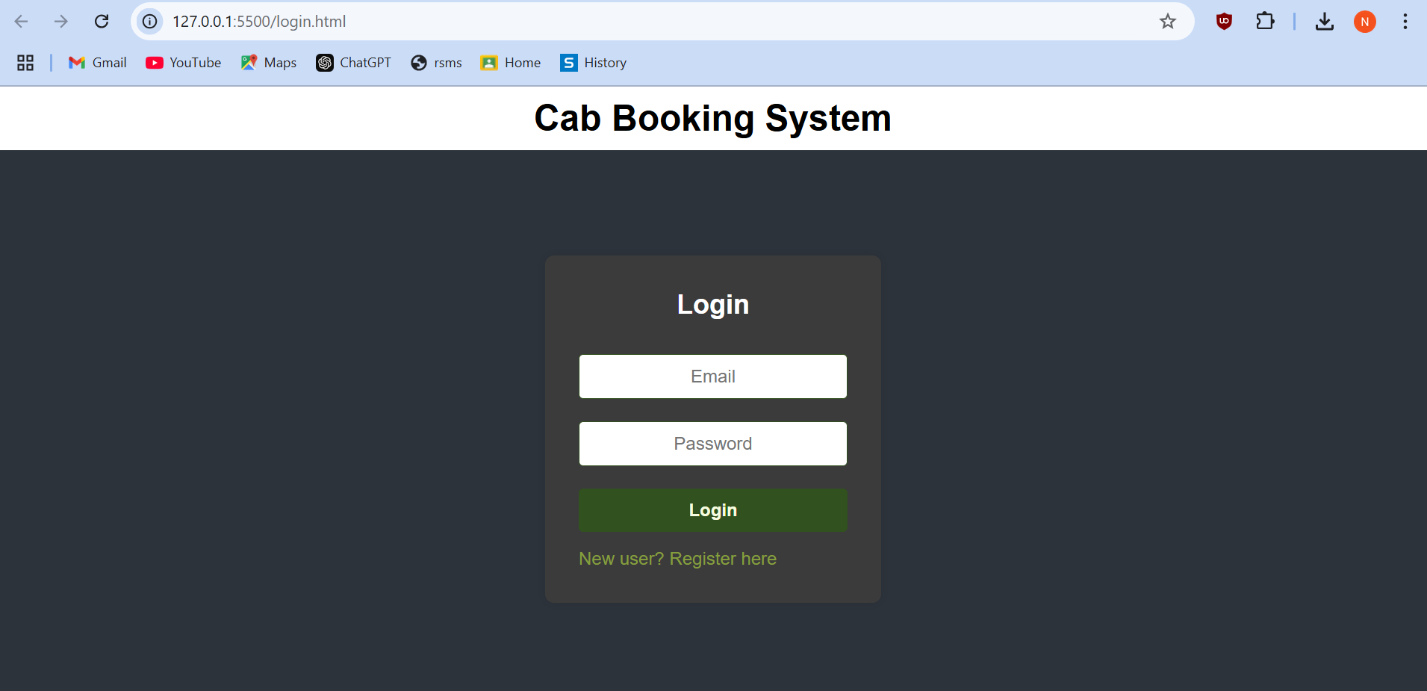



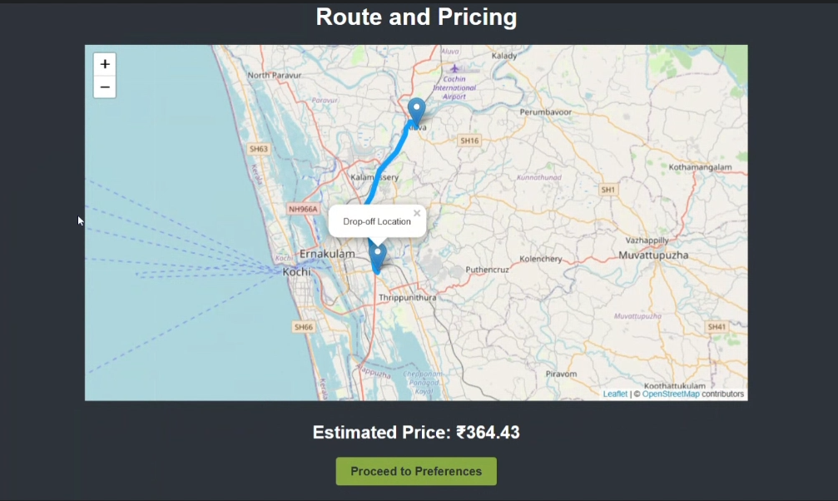
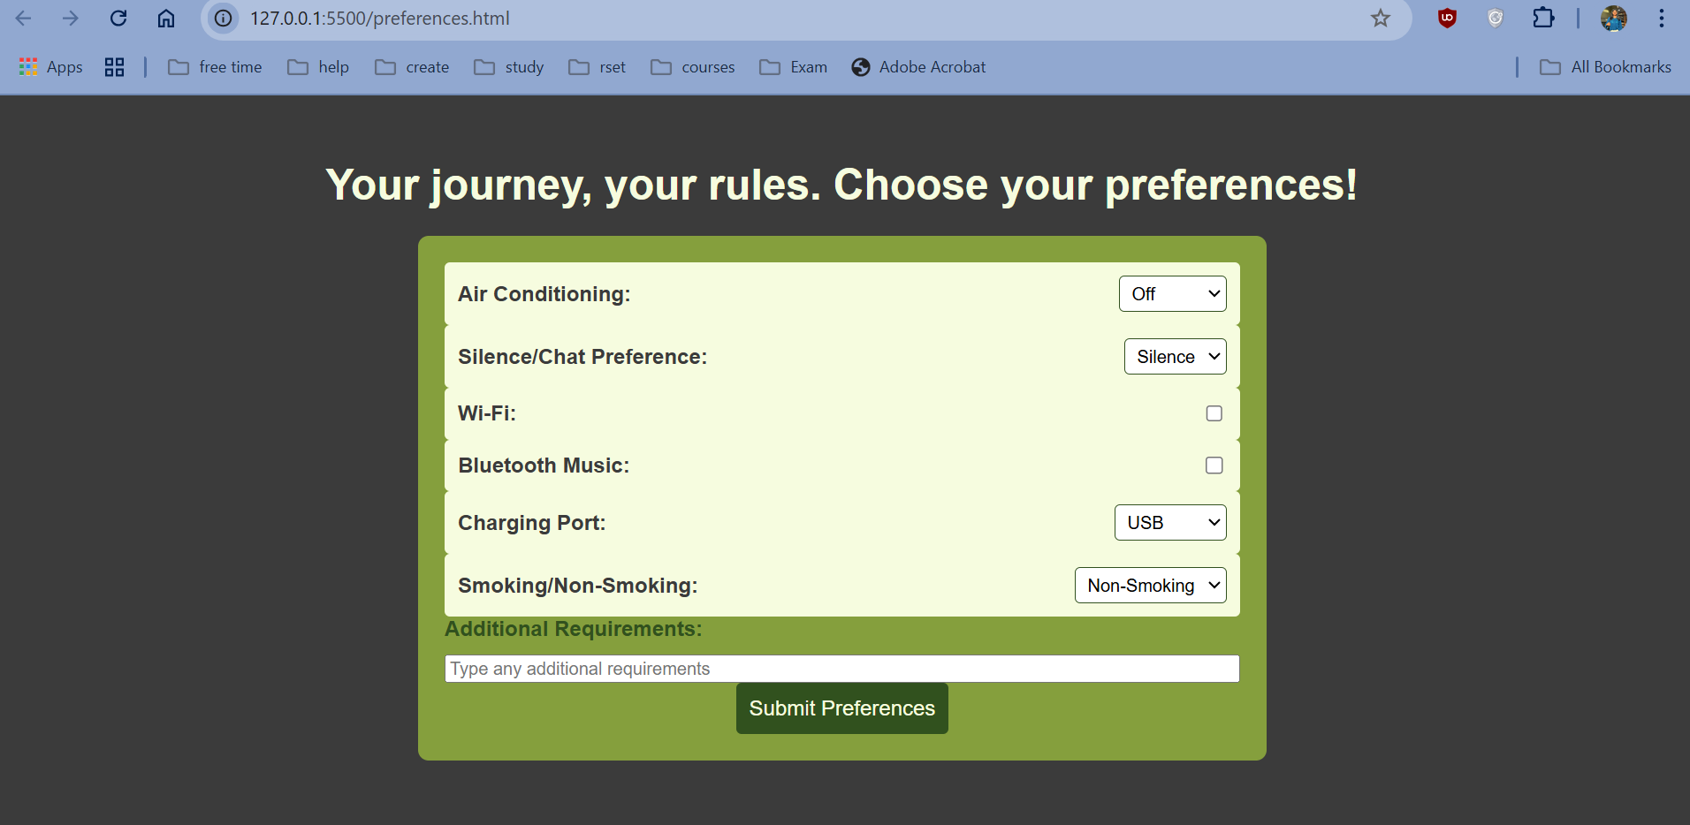

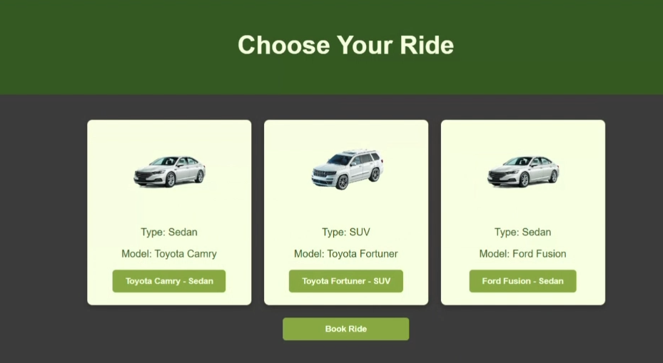
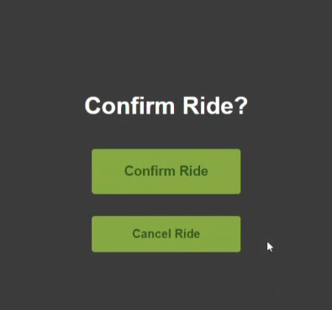
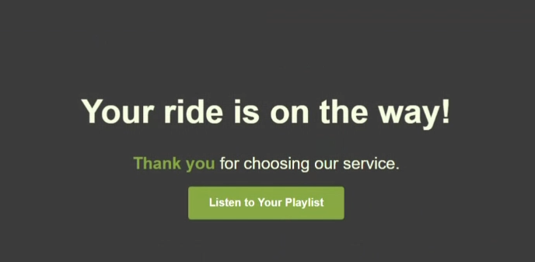
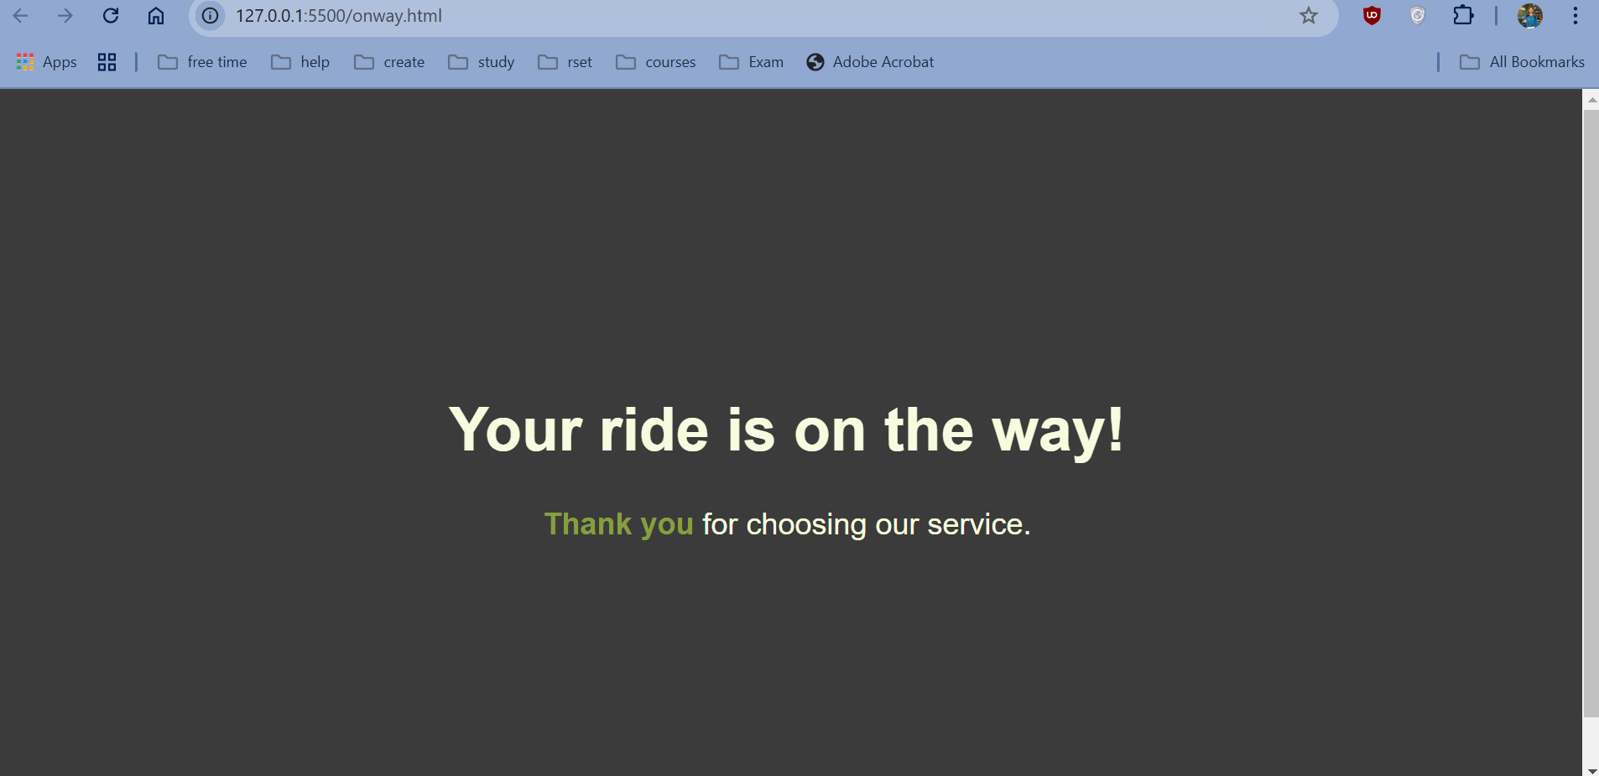
CONCLUSION

Quick Cab is a modern, user-centered transportation solution that blends advanced technology with personalization to offer a seamless cab booking experience. With an intuitive interface powered by HTML, CSS, and JavaScript, Quick Cab makes it easy for users to register, manage profiles, set pickup and drop-off locations, and customize preferences. Integrated map APIs ensure precise location selection, enhancing convenience even in unfamiliar areas.

Personalization is at the heart of Quick Cab, offering features like temperature control, Wi-Fi, Bluetooth, and Spotify integration, allowing passengers to tailor their ride to their needs. The backend, built with PHP and SQL, ensures secure user data management, and strict security measures protect personal and payment information.

Quick Cab’s real-time fare estimation promotes transparency, allowing users to confidently budget their trips without hidden charges. With flexible options to confirm, cancel, or modify bookings, users have full control over their ride experience. The service is continuously evolving based on customer feedback, ensuring comfort, convenience, and satisfaction.
Designed with a customer-first approach, Quick Cab combines speed, flexibility, and customization, aiming to redefine urban mobility. Looking ahead, the platform plans to expand with eco-friendly vehicles, accessibility features, and AI-driven route optimization, ensuring a reliable and personalized transportation experience.

REFERENCES

MDN Web Docs - HTML & CSS: Comprehensive guides on HTML and CSS for structuring and styling web pages, covering syntax, best practices, and examples.
- https://developer.mozilla.org/en-US/docs/Web/HTML
- https://developer.mozilla.org/en-US/docs/Web/CSS
MDN Web Docs - JavaScript Guide: A thorough guide for JavaScript fundamentals and advanced features, ideal for adding interactivity.
- https://developer.mozilla.org/en-US/docs/Web/JavaScript/Guide
PHP Official Documentation: Provides in-depth information on PHP for server-side scripting and data handling.
- https://www.php.net/manual/en/index.php
W3Schools - SQL Tutorial: Introductory and advanced SQL tutorials for creating, managing, and querying databases.
- https://www.w3schools.com/sql/
OpenRoute Service API Documentation: Guide for implementing OpenRoute Service, used for mapping locations and route suggestions.
- https://openrouteservice.org/
YouTube Tutorials: Learning specific implementation techniques and visual demonstrations.
- https://youtu.be/1cq07pju1rs?si=WZmhntdhEEcwqy1W
- https://youtu.be/VCHXCusltqI?si=g9QybEz_TsWR97bb

